

WORLD PEACE UNIVERSITY

M.TECH PROJECT REPORT ON

PREDICTION OF HEART DISEASE
USING NEURAL NETWORK

MASTER OF TECHNOLOGY(2017-2019) ELECTRONICS AND COMMUNICATION ENGINEERING VLSI AND EMBEDDED SYSTEMS

BY

KUNAL D. KHOSLA

205216

UNDER THE GUIDANCE OF

PROF. ALWIN D. ANUSE

DEPARTMENT OF ELECTRONICS & COMMUNICATION

ENGINEERING

MIT WORLD PEACE UNIVERSITY

PAUD ROAD, KOTHRUD, PUNE-411038

CERTIFICATE


This is to certify that the project entitled

Prediction of Heart Disease using Neural Network

Submitted by

Kunal Deepak Khosla

Is a bonafide work carried out by him under the guidance of
Prof. Alwin D. Anuse and it is approved for the partial fulfilment of the requirement of the Triseme IV, Subject: Artificial Intelligence Techniques and Applications during the academic year 2017-2019 (Electronics & Communication Engineering, VLSI and EMBEDDED systems).

Subject : Artificial Intelligence Techniques and Applications

Guide: Prof. Alwin D. Anuse

Place: Pune

Date: 6-10-2018

ABSTRACT

The Project titled ‘Prediction of Heart Disease using Neural Network’ is an attempt to aid prediction of early stage heart ailments that can lead to effective prognosis so as to minimize or lessen the damage due to heart related ailments. Cardiovascular Diseases is what’s killing Indians. Roughly 1415.6 men and 1121.3 cases of death (per 100,000 people) have been reported due to cardiovascular problems in the year 2014. The main factors responsible are high blood pressure, Unhealthy Lifestyle, Family History, Obesity, Smoking etc.

Due to the busy and fast-paced life of the common man, these symptoms or likely causative factors are ignored leading to unforeseen risk. This prediction system plans and foresees the risk level of patients in view of the given parameters of Health.

The neural network was trained with patient data (train data-180 samples with 14 attributes, test data – 91 samples with 14 attributes). The source of this data was Driven Data: Warm-up Machine Competition. The model uses 1 hidden layers, 1 output and 1 input layer. Four important features were selected to train the model. Crossentropy (Log Loss) was used to evaluate the performance of the model. The code has been written Using Python in Jupyter Notebook with the help of Libraries like Numpy, Pandas and Keras Framework.

CONTENTS

- Introduction…………………………………………………………….

1.1. Scope of Project…………………………………………………….

1.2. Organization of Report……………………………………………

- Literature Survey………………………………………………………

2.1. Present Scenario……………………………………………………..

- System Development and Design ………………………………………

3.1. System Specifications……………………………………….
3.2. System Block Diagram……………………………………….
3.3. Binary Cross Entropy Loss……………………………………..

- Implementation of System…………………………………………………

5.1. Algorithms/Code or techniques used………………………………………….

- Results………………………………………………………………………

5.1. Conclusion……………………………………………………………...

5.2. Future Scope…………………………………………………………….

References……………………………………………………………………

LIST OF FIGURES

SR. NO | NAME OF FIGURE | PAGE NO
3.1 | Main System Block Diagram
3.2 | Number of patients with(1) and without(0) heart disease
3.3 | Dataset in tabular form(not all attributes covered)
3.4 | Relationship between our features and labels
3.5 | Relu and Sigmoid Activation functions
3.6 | Perceptron model(left) and Binary Cross Entropy Formula(right)
4.1 | Screenshot of rank obtained after submission for competition
4.2 | Screenshot of training process using keras
4.3 | Screenshot of result obtained

CHAPTER 1

1. INTRODUCTION

The Report is a study of prediction of Heart disease problems using Neural Network. The Project was a challenge at first as feature selection posed a major hurdle but with the help of heat maps, correlation this too seemed easy.

The project is a first of its kind for me as it involves some knowledge of ANN (Artificial Neural Network). Luckily, I had my basics cleared and it helped me complete the project.

Heart ailments are a major catastrophe in terms of finances and health. They can be prevented with good and healthy choices of Lifestyle. Increasingly, people are getting more aware of the risk and we see the changes but sometimes we cannot help it due to our work or other conditions, ignorance is natural. But, with AI Techniques such as this project, risk can be evaluated in a manner leading to effective prognosis and thus better diagnosis.

This model if trained better can be used by technicians, health groups, health drives, and doctors etc. to warn adults with increasing risk of heart related ailments. It is especially recommended after the age of 30 years that one must get a thorough check-up done once every 2 to 3 years (even if your healthy, do not smoke etc.)

Scope Of Project

Data Mining Techniques have been recently used in coming up with effective results to foresee medical conditions. Data mining offers promising results in evaluating the risk of heart diseases at an early stage. Regular visits to the hospital and finding specialists is often impossible and not feasible to the common man. By Predicting, the risk of heart ailments or presence of heart disease, countless lives can be saved driving adults and high risk teenagers to a healthier lifestyle, but that does not mean we stop caring about our health and leave it to the professionals or Artificial Intelligence to track us down. These systems are at a development stage and deployment of AI techniques or software to gather information and track down patients with risk of heart disease will still take time. Sometimes risks can be avoided by proper care at an early stage and that’s when one becomes serious about their health.

Nowadays, heart disease is increasing day by day due to lifestyle. Especially, Heart diseases are becoming more common these days. This prediction system can give us the chances of presence of Heart Disease or classify the results into binary class where zero tells us about the class Heart disease not present and one about Heart Disease Present. The system can be made more accurate by:
- Selecting more features
- Increasing the batch size

The system is not very sophisticated as of now but new features and increasing the data size can lead to more accurate results. More Research about the contribution of relevant features in the prediction can help us make better models. Lack of Knowledge at this stage made it a difficult task. As mentioned earlier, one can play with the parameters and tune the model to achieve the desired result. Although since we are predicting a value, (an indicator of presence of heart disease) Logistic Regression can be tried to approach this problem.

Organization of Report

The project focuses on prediction, so the report has been organized on the same lines. In Prediction we try to come up with values also known as Regression.

- Chapter 1: Introduction and scope
This chapter provides an overview of the basic functionality of the system and describes its scope of expansion
- Chapter 2: Literature Survey and present scenario
This chapter enlightens the literature survey of the work done in this field so far as well as the present scenario.
- Chapter 3: System Block Diagram and Flow Chart
Explains in detail the design and development process of the system. Includes system specifications block diagram, description of each block.
- Chapter 4: System Design
It includes all the algorithms used for feature extraction and prediction.
- Chapter 5: Implementation
It includes schemes(code) used to evaluate the chances of a man getting a heart disease.

- Chapter 6: Results and Conclusion
Includes results, future scope, applications and conclusion
CHAPTER 2

2. LITERATURE SURVEY

While researching about how to learn machine learning techniques and dive into artificial intelligence I came across many articles, papers and websites devoted to this field.
After reading through these research papers I got an idea or head start for our project.

The material across the web was vast when it comes to Machine Learning but I was able to stick to one problem statement due to a completion posted on Driven Data. This site hosts several challenges to budding Machine learning users and enables us to polish our skills in this field. The site hosted a Warm Up: Machine Learning with a Heart challenge, and it described the challenge to involve one of the smallest datasets. It read “We've all got to start somewhere. This is one of the smallest datasets on DrivenData. That makes it a great place to dive into the world of data science competitions. Get your heart thumping and try your hand at predicting heart disease.”

That is what provoked me to take on this challenge as it was a prediction challenge at heart.
While going about this project on AI, I faced many challenges as it was completely new to me, but the Machine Learning Mastery site made it pretty easier. It gave me a flow to work with which helped me to reach the goal faster.

Also the engaging meetup groups with Vipul and Vineet were a great source of inspiration. They hold regular meetups which focus on learning the basics of Machine Learning.

Moreover, the biggest hurdle for me in this project was Feature Selection. For this topic I took help from a book by O’Reilly Publications titled “Thoughtful Machine Learning with Python”. The chapter on Improving Models and Data Extraction gave me some idea about how to select features from a given data, the techniques given is minimum Redundancy Maximum Relevance approach. But to my understanding the features did not give the required accuracy (only 57%). So I visited Driven Data Labs where the selected features were already given, so I used the same for my project. The accuracy improved in the latter case (67%).

To evaluate the performance of the problem I used a cross entropy based log loss function, I took the help from http://neuralnetworksanddeeplearning.com and https://gombru.github.io/2018/05/23/cross_entropy_loss/. Chapter no 3 from this website was referred for this purpose. In the context of prediction I choose binary cross entropy to be our loss function as the training data had binary labels in them. Adam optimizer was choosen as the gradient descent optimization algorithm. One can refer http://ruder.io/optimizing-gradient-descent/ for more detail on optimizers.

To learn to code in Python I regularly took help from online documentation especially from keras.io for information on how to model neural networks using Keras. Also, the 3 day workshop on Python conducted on MIT premises served as a great base to set up my Warm-Up Machine.

Playing with new features like number of features selected and analysis of overfitting have been added to future scope of the project.

2.1 Present Scenario

According to the paper titled “Efficient Heart Disease Prediction System” by Purushottam et. al “In today's opportunity at numerous spots clinical test outcomes are regularly made in light of specialists' instinct and experience as opposed to on the rich data accessible in numerous expansive databases. Numerous a times this procedure prompts inadvertent predispositions, lapses and a tremendous medicinal expense which influences the nature of administration gave to patients.

Today numerous doctor's facilities introduced some kind of quiet's data frameworks to man-age their social insurance or patient information. These data frameworks commonly produce a lot of information which can be in distinctive organization like numbers, content, diagrams and pictures yet sadly, this database that contains rich data is once in a while utilized for clinical choice making.

Like business knowledge and examination, the term information mining can mean diverse things to distinctive individuals. In exceptionally straightforward way we can characterize information mining as this is the investigation of substantial information sets to discover examples and utilize those examples to foresee or fore-cast the probability of future occasions. The motivation to do this problem comes from World Health Organization estimation. According to the World Health Organization estimation till 2030, very nearly 23.6 million individuals will pass on because of Heart malady. So to minimize the danger, expectation of coronary illness ought to be finished. Analysis of coronary illness is typically in view of signs, manifestations and physical examination of a patient. The most troublesome and complex assignment in medicinal services area is finding of right ailment.”
The paper further examines and tells about a framework proposed by Heon Gyu Lee et al and various classifiers like “CMAR (Classification Multiple Association Rules), SVM (Support Vector Machine), Bayesian Classifiers” which are being used by various experts in the field.

CHAPTER 3

SYSTEM DEVELOPMENT AND DESIGN

3.1 System Specifications

The aim of the project is to predict the chances of the person getting a heart disease. The Operating System used was Windows 10 environment. The processor runs on a 64 bit OS with Intel Core i5-7200U CPU @2.5 GHz. The platform or environment used to design the system was Jupyter Notebook tool from Anaconda with pre-installed libraries especially keras. The Code was written in Python and the data was available in csv(Comma separated Values) format. For Data Visualization, seaborn plots where used.

The Dataset was available as:
- train_values: 181 records with 14 attributes or columns.
- Train_labels: patient_id with class(heart_disease_present 0,1)
- test_values: 91 records with attribute format mainly in int64 format. There were a total of 14 columns namely:-

- slope_of_peak_exercise_st_segment (type: int): the slope of the peak exercise ST segment, an electrocardiography read out indicating quality of blood flow to the heart
- thal (type: categorical): results of thallium stress test measuring blood flow to the heart, with possible values normal, fixed_defect, reversible_defect
- resting_blood_pressure (type: int): resting blood pressure
- chest_pain_type (type: int): chest pain type (4 values)
- num_major_vessels (type: int): number of major vessels (0-3) colored by flourosopy
- fasting_blood_sugar_gt_120_mg_per_dl (type: binary): fasting blood sugar > 120 mg/dl
- resting_ekg_results (type: int): resting electrocardiographic results (values 0,1,2)
- serum_cholesterol_mg_per_dl (type: int): serum cholestoral in mg/dl
- oldpeak_eq_st_depression (type: float): oldpeak = ST depression induced by exercise relative to rest, a measure of abnormality in electrocardiograms
- sex (type: binary): 0: female, 1: male
- age (type: int): age in years
- max_heart_rate_achieved (type: int): maximum heart rate achieved (beats per minute)
- exercise_induced_angina (type: binary): exercise-induced chest pain (0: False, 1: True)

3.2 System Block Diagram

The main components are:

Data Collection & Pre-processing

(Libraries Used: Pandas,numpy)
Feature Selection

(Research Based)
Training and testing

(using Keras model with 1 hidden layers)

Fig 3.1 Main System Block Diagram

- Data Collection and Pre-Processing: This was done to scale the values to integers in a specific range so as to obtain uniformity. Since patient_id was irrelevant after the target was merged to the train_values, it was removed. One can see the balance or equalization of the 2 classes (0 and 1) so that there is no bias as seen in figure 3.2. The data obtained finally is as shown in figure 3.3.
- Feature Selection: As per research on heart diseases the most commonly selected features found to be where age, sex, max_heart_rate_achieved and resting_blood_pressure (Source: Driven Data Labs). Another aspect not highlighted is data visualization, by analysing the visual or graphical data one can get an idea of which features are relevant and which are not. This is shown in figure 3.4. It describes the relationship between the selected features and heart disease label.
- Training and Testing: As mentioned earlier, keras sequential model was chosen to set up our model consisting of 12 neurons in the input layer, 8 in the hidden layer and an output neuron. Relu and sigmoid activation functions were used as shown in figure 3.5. The model uses Adam optimizer and binary cross entropy (Figure 3.6) as our loss function to predict the values.
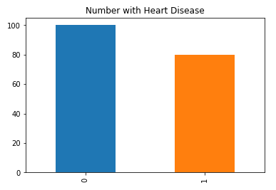
Fig 3.2 No of patients with(1) and without(0) heart disease

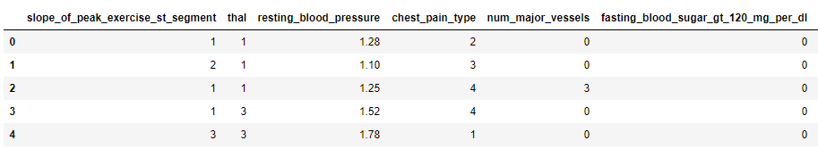
Fig 3.3 Dataset in tabular form(not all attributes covered)

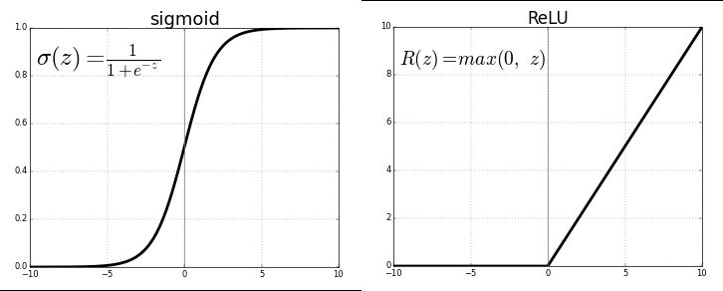
Fig 3.5 Relu and Sigmoid Activation functions

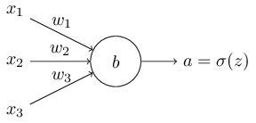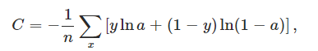
Fig 3.6 Perceptron model(left) and Binary Cross Entropy Formula(right)

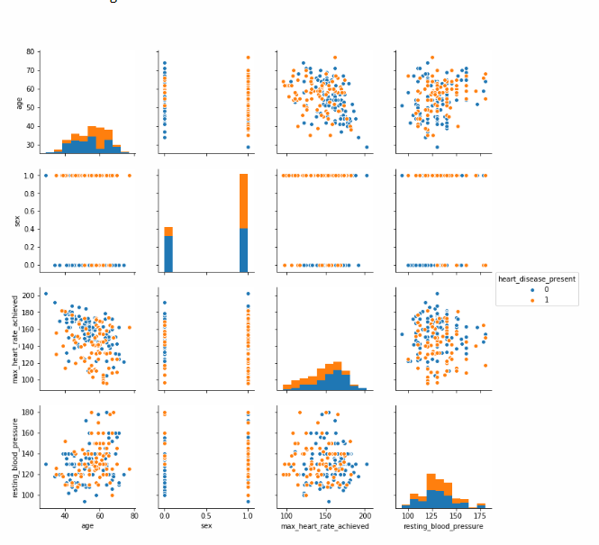

Fig 3.4 Relationship between our features and labels. Source(Driven Data Labs)

3.3 Binary Cross Entropy Loss

It is also called Sigmoid Cross-Entropy loss. It is a Sigmoid activation plus a Cross-Entropy loss. Due to a slowdown in learning in during neural network, cross entropy offers a faster way to achieve the desired goal. It is a type of log loss which tells us that the rate at which the weight learns is controlled by actual output – desired output. In particular it avoids the learning slowdown caused by the extra first derivative in the quadric cost function.

So, to summarize in our model we chose 3 layers and added relu and sigmoid activation factions as will be seen in the code. The model was compiled with the help of binary cross entropy loss and adam optimizer. The no of epochs chosen were 180 with a batch size of 10. This means that a size of 10 samples was used in one iteration. So, 18 iterations were required to complete 1 epoch. The model was built on keras. Keras runs with tensorflow in the backend. “Keras is a model-level library, providing high-level building blocks for developing deep learning models. It does not handle itself low-level operations such as tensor products, convolutions and so on. Instead, it relies on a specialized, well-optimized tensor manipulation library to do so, serving as the "backend engine" of Keras”.(Source: keras.io)

Dense implements the operation: output = activation(dot(input, kernel) + bias) where activation is the element-wise activation function passed as the activation argument, kernel is a weights matrix created by the layer, and bias is a bias vector created by the layer (only applicable if use_bias is True). Compile configures the model for training. Fit trains the model for a given number of epochs. Evaluate returns the loss values and metrics for the model in test mode. Predict generated predictions for the input samples. Computation is done in batches.

CHAPTER 4

IMPLEMENTATION OF SYSTEM

- The .csv files containing the data was loaded into variables of type pandas.core.frame.Dataframe with the help of pandas library. The code snippet is attached below for reference.
- After the data was loaded irrelevant features like patient_id were removed and data was normalized to include only integer values like chest_pain_type was classified into 1,2 or 3. The attributes like blood pressure, heart rate and cholesterol were divided by 100 to bring it down to the range from 1-10 where our dataset lies.
- Then the data was merged with out labels.csv file to include target attribute.
- For Data Visualization, a python library called seaborn was used. The graphs obtained are called pair-plots.
- The neural network model using Sequential method was designed and only the selected features were selected to be used in the model.
- The model created had 1 input layer with 12 neurons, 1 hidden layer with 8 neurons and 1 output neuron. The model was trained to learn via supervised learning on the training data.
- Finally the test data after normalization (Repeat Step.2 for test data) was passed onto the neural network to predict the chances of heart ailments.

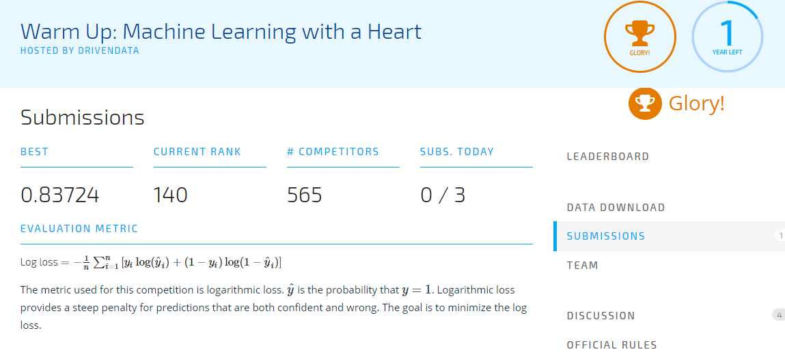
Fig 4.1 Screenshot of rank obtained after submission for competition (Source:DrivenData)

4.1 Algorithms/Code or techniques used

Code:

#data preprocessing
%matplotlib inline
import pandas as pd
import numpy as np

hdata = pd.read_csv("train_values.csv")
hlabel = pd.read_csv("train_labels.csv")

hdata.max_heart_rate_achieved=(hdata.max_heart_rate_achieved)/100
hdata.resting_blood_pressure=(hdata.resting_blood_pressure)/100
hdata.serum_cholesterol_mg_per_dl=(hdata.serum_cholesterol_mg_per_dl)/100
hdata.thal=hdata.thal.replace("normal",1)
hdata.thal=hdata.thal.replace("fixed_defect",2)
hdata.thal=hdata.thal.replace("reversible_defect",3)
df=pd.merge(hdata,hlabel)
hdata.drop(['patient_id'], axis = 1, inplace = True)
df.drop(['patient_id'], axis=1, inplace = True)

#Data Visulization
selected_features=['age','sex','max_heart_rate_achieved','resting_blood_pressure']
#selected_features=['thal','oldpeak_eq_st_depression','age','exercise_induced_angina']
import seaborn as sns
sns.pairplot(df,hue='heart_disease_present',vars=selected_features)

from keras.models import Sequential
from keras.layers import Dense
selected_features=['age','sex','max_heart_rate_achieved','resting_blood_pressure']
X=df[selected_features]
Y=df['heart_disease_present']

#create model/train
model=Sequential()
model.add(Dense(12, input_dim=4, activation='relu'))
model.add(Dense(8, activation='relu'))
model.add(Dense(1, activation='sigmoid'))
model.compile(loss='binary_crossentropy', optimizer='adam', metrics=['accuracy'])
model.fit(X, Y, epochs=180, batch_size=10)

# evaluate the model
scores = model.evaluate(X, Y)
print("\n%s: %.2f%%" % (model.metrics_names[1], scores[1]*100))

#testing
pdata = pd.read_csv("test_values.csv")

pdata.max_heart_rate_achieved=(hdata.max_heart_rate_achieved)/100
pdata.resting_blood_pressure=(hdata.resting_blood_pressure)/100
pdata.serum_cholesterol_mg_per_dl=(hdata.serum_cholesterol_mg_per_dl)/100
pdata.thal=hdata.thal.replace("normal",1)
pdata.thal=hdata.thal.replace("fixed_defect",2)
pdata.thal=hdata.thal.replace("reversible_defect",3)
selected_features=['age','sex','max_heart_rate_achieved','resting_blood_pressure']
predict=pdata[selected_features]
col1=pdata['patient_id']

# calculate predictions
predictions = model.predict(predict)
# round predictions
rounded = [(x[0]) for x in predictions]

#Displaying Result
result={'Patient ID':col1,'Chances of Heart Disease(in%)':rounded}
R=pd.DataFrame(result)
R

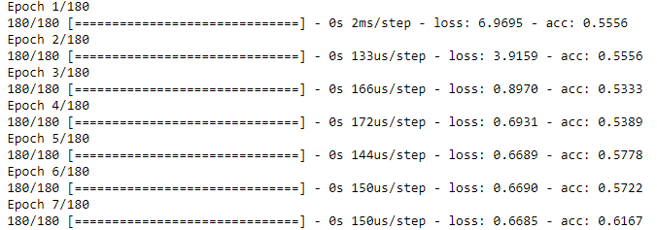
Fig 4.2 Screenshot of training process using keras

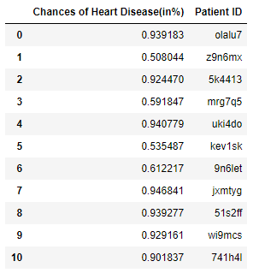
Fig 4.3 Screenshot of Result Obtained

CHAPTER 5

RESULTS

5.1 Conclusion

The screenshots of the training and result are shown in Figure 4.2 and 4.3 respectively. Submission results can be seen in Figure 4.1. The final accuracy obtained was close to 70% . The time taken during training was in seconds and the prediction happened almost instantly.

5.2 Future Scope

The system is not very sophisticates in the sense that it does not evaluate the risk level, only the percentage of it happening is obtained. A risk category can be obtained by a formula and then added to the system to make it more complete and useful for Practioners, doctors, data scientists etc. Also this system relied on Research Labs (Driven Data Labs) for the feature Selection. The study of features and extensive domain knowledge in cardiovascular problems can be very useful in assessing the usefulness of these features. The future researchers can play with parameters like batch size, number of epochs to obtain a higher accuracy rate, the model currently relies on inbuilt features of Keras Libraries. A high level knowledge and practical experience of these libraries can be useful to build better models with higher prediction rates. Also the data set was quite limited, a vast dataset can be used to obtain the results. Also another feature that can be added is an analysis of overfitting and generalization to allow for detection of outliers. This is very useful and dropouts or regularization can be useful in this regard. In order to conclude one can try different activation functions and play with these parameters to obtain higher accuracy.

REFERENCES

- https://machinelearningmastery.com
- https://www.drivendata.org
- http://drivendata.co/blog/machine-learning-with-a-heart-benchmark/
- https://machinelearningmastery.com/how-to-make-classification-and-regression-predictions-for-deep-learning-models-in-keras/
- https://keras.io/
- http://neuralnetworksanddeeplearning.com/chap3.html

